Given an m x n binary grid grid where each 1 marks the home of one friend, return *the minimal****total travel distance***.

The **total travel distance** is the sum of the distances between the houses of the friends and the meeting point.

The distance is calculated using [Manhattan Distance](http://en.wikipedia.org/wiki/Taxicab_geometry), where distance(p1, p2) = |p2.x - p1.x| + |p2.y - p1.y|.

**Example 1:**

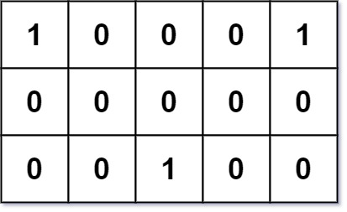

**Input:** grid = [[1,0,0,0,1],[0,0,0,0,0],[0,0,1,0,0]]

**Output:** 6

**Explanation:** Given three friends living at (0,0), (0,4), and (2,2).

The point (0,2) is an ideal meeting point, as the total travel distance of 2 + 2 + 2 = 6 is minimal.

So return 6.

**Example 2:**

**Input:** grid = [[1,1]]

**Output:** 1

**Constraints:**

* m == grid.length
* n == grid[i].length
* 1 <= m, n <= 200
* grid[i][j] is either 0 or 1.
* There will be **at least two** friends in the grid.